Dear Students,

- Have you ever wondered what it would be like to explore a beautiful, tropic country and learn in the process?
- Do you feel stuck academically and need some motivation or purpose to get you going?
- Does it interest you that if you study abroad, you are more likely to graduate, get a job, and get into graduate school?*
- Have you considered providing physical or mental health services in Spanish in your future career?
- Would you like your college path enriched beyond the classroom and possibly have a life-changing experience?
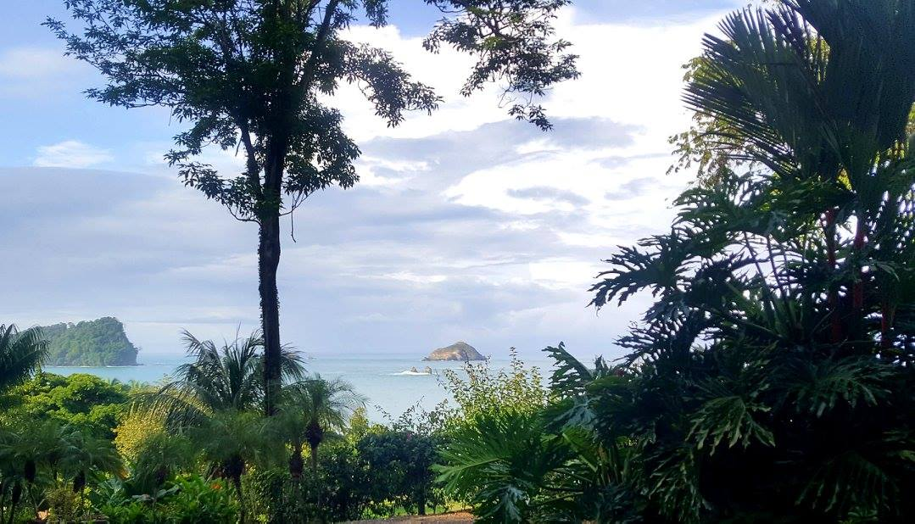

If you said yes to one or more of these questions, study abroad may be an excellent choice for you and we have financial aid to assist you! On behalf of the Healthcare Spanish Certificate Program housed in the College of Arts and Letters, we introduce you to the Costa Rica summer program! You have the option of going on the following dates in 2017:

2 week program: June 24- July 10
4 week program: June 24-July 24

The program will consist of learning about health in Costa Rica and you will have the chance to interact directly with patients and clients! You also will be given the chance to sightsee this wondrous country pura vida (full of life, a common saying in Costa Rica).

If you would like to learn more, please attend one of our info sessions:

- Tuesday 2/21, 12:30 pm in Health & PE Complex/Coussoulis Arena, Room 117
- Wednesday, 2/22, 3 pm in Social & Behavioral Sciences, Room 212

Presidential Award of $500 will be given to CSUSB matriculated students.
Financial Aid available. Scholarships available.

If you have any questions about the program or information sessions, please contact Manijeh Badiee, mbadiee@csusb.edu or Guillermo Escalante, gescalante23@yahoo.com.

Have a wonderful day and we hope to see you soon!

Manijeh Badiee

Assistant Professor of Psychology
Costa Rica Program Coordinator
College of Social & Behavioral Sciences
California State University, San Bernardino
5500 University Parkway
San Bernardino, CA 92407
(909) 537-7305
http://psychology.csusb.edu/facultystaff/manijeh_badiee.htm
mbadiee@csusb.edu

Guillermo Escalante

Assistant Professor of Kinesiology
Costa Rica Program Coordinator
College of Natural Sciences
California State University, San Bernardino
5500 University Parkway
San Bernardino, CA 92407
(909) 537-7236
gescalante23@yahoo.com

*Data collected from various sources through http://studyabroad.ucmerced.edu/study-abroad-statistics/statistics-study-abroad

