Are you interested in immersing yourself into a new culture?
Would you like to get to know people who are known for being kind, open-hearted, and happy?
Do you want to spend part of your summer exploring luscious green forested beaches, colorful wildlife, and delicious, fresh cuisine?
Are you interested in learning more about providing health care services in Spanish?
Come to our information session to learn more about the Costa Rica Summer Experience!
Info Session
2017 Costa Rica Summer Program
Tuesday 2/21, 12:30 pm in HP 117
Wednesday, 2/22, 3 pm in SB 212

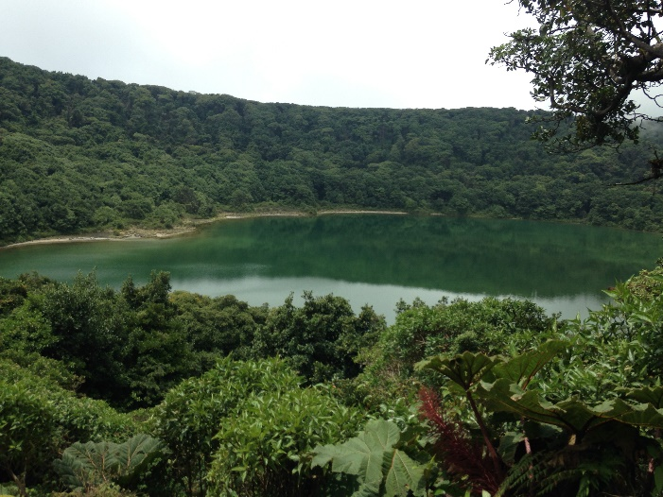 | 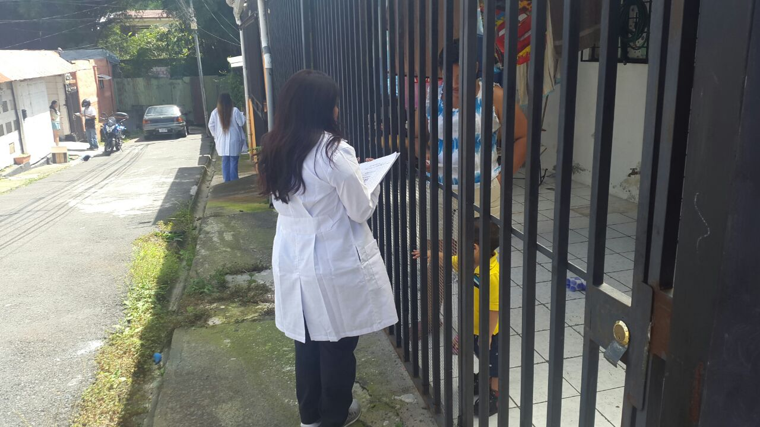

Come learn about what our program has to offer and whether it is a good fit for you!

